Technical Guide

Selection-Sort Visualizer

Flow Chart:

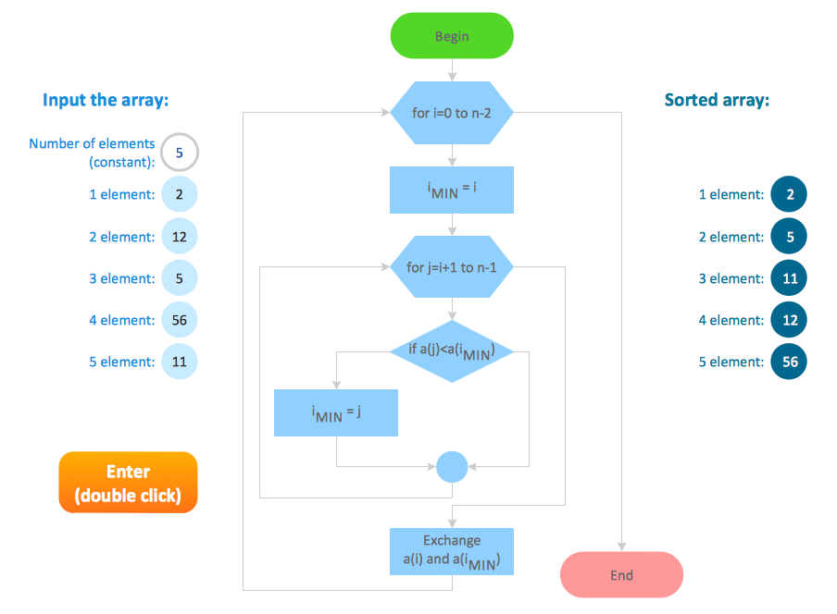

Functions used:
Button1_Click(ByVal sender As Object, ByVal e As EventArgs) Handles sort.Click: This function decides what will happen when we hit Sort button.
Textbox.clear(): This function clears the Textbox, Whatever User wrote will be cleared.
Typecasting: This usually typecast one data type to otherone.
Trim(): This will trim the string from left and right both the sides.
Splilt(string,” “): This function will split the string whenever a space is recorded.
String.length : This function Will return the size of string.
System.windows.form.button: This will form a button.
Messagebox.show(): This will bring a popup box having some warning.
Radiobutton.checked: This will check that radiobutton is check or not.
Me.graph.Series("Graph").Points.AddXY(integer,integer): This will add points on the graph as x axis and y axis.
Graph.location: Used to provide a location for the graph.
Graph.size: Generate’s a size for the graph.
Graph.visible: It is a boolean type which checks that is true or false.
.Tag = n + 1 : Tag of button for the visualization part.
.Width = 43 : Width of button for the visualization part.
.Height = 43 : Height of button for the visualization part.
.Top = yPosition : y coordinate of button for the visualization part.
.Left = xPosition : x coordinate of button for the visualization part.
Delay(): A user defined function which provides a time delay for button and graph bar used for visualization of the selection-sort.
graph.Series("Graph").Points(i).Color: Add’s colour to the bar of the graph.
btnArray(j).BackColor: Add’s colour to the button for array representation.
Join(string,” “): This joins the splitted string with space seperated entries.
Me.Controls.Remove(tmpbtnArray(i)): Removes the ith button fon the button array!
graph.Series("Graph").Points.Clear(): when the sorting is done the graph will be cleared.
TextBox1_KeyPress(ByVal sender As Object, ByVal e As KeyPressEventArgs) Handles TextBox1.KeyPress: This is to check what User has entered in the space provided for input.
String.IsNullOrEmpty(TextBox1.Text): this will check that string is Null or Empty if yes then returns true, else False.
Asc(e.KeyChar): This returns the ascii value of the character entered by the user.
Form1_Load(ByVal sender As System.Object, ByVal e As System.EventArgs) Handles MyBase.Load: This will load the graphics of the form.
Now.AddSeconds(onesec): Add’s one second of delay time.
Application.DoEvents(): After the delation do the event.
Public Function RemoveWhiteSpaces(ByVal text As String) As String: This function removes the Two or more consecutive white spaces in the string (INPUT).
Reset.PerformClick(): Generates a reset event for the control, simulating a click by a user.
ExitButton_Click(ByVal sender As System.Object, ByVal e As System.EventArgs) Handles ExitButton.Click: This function decides what will happen when we hit Exit button.
Me.Close(): This exits the application.

Some corner cases:
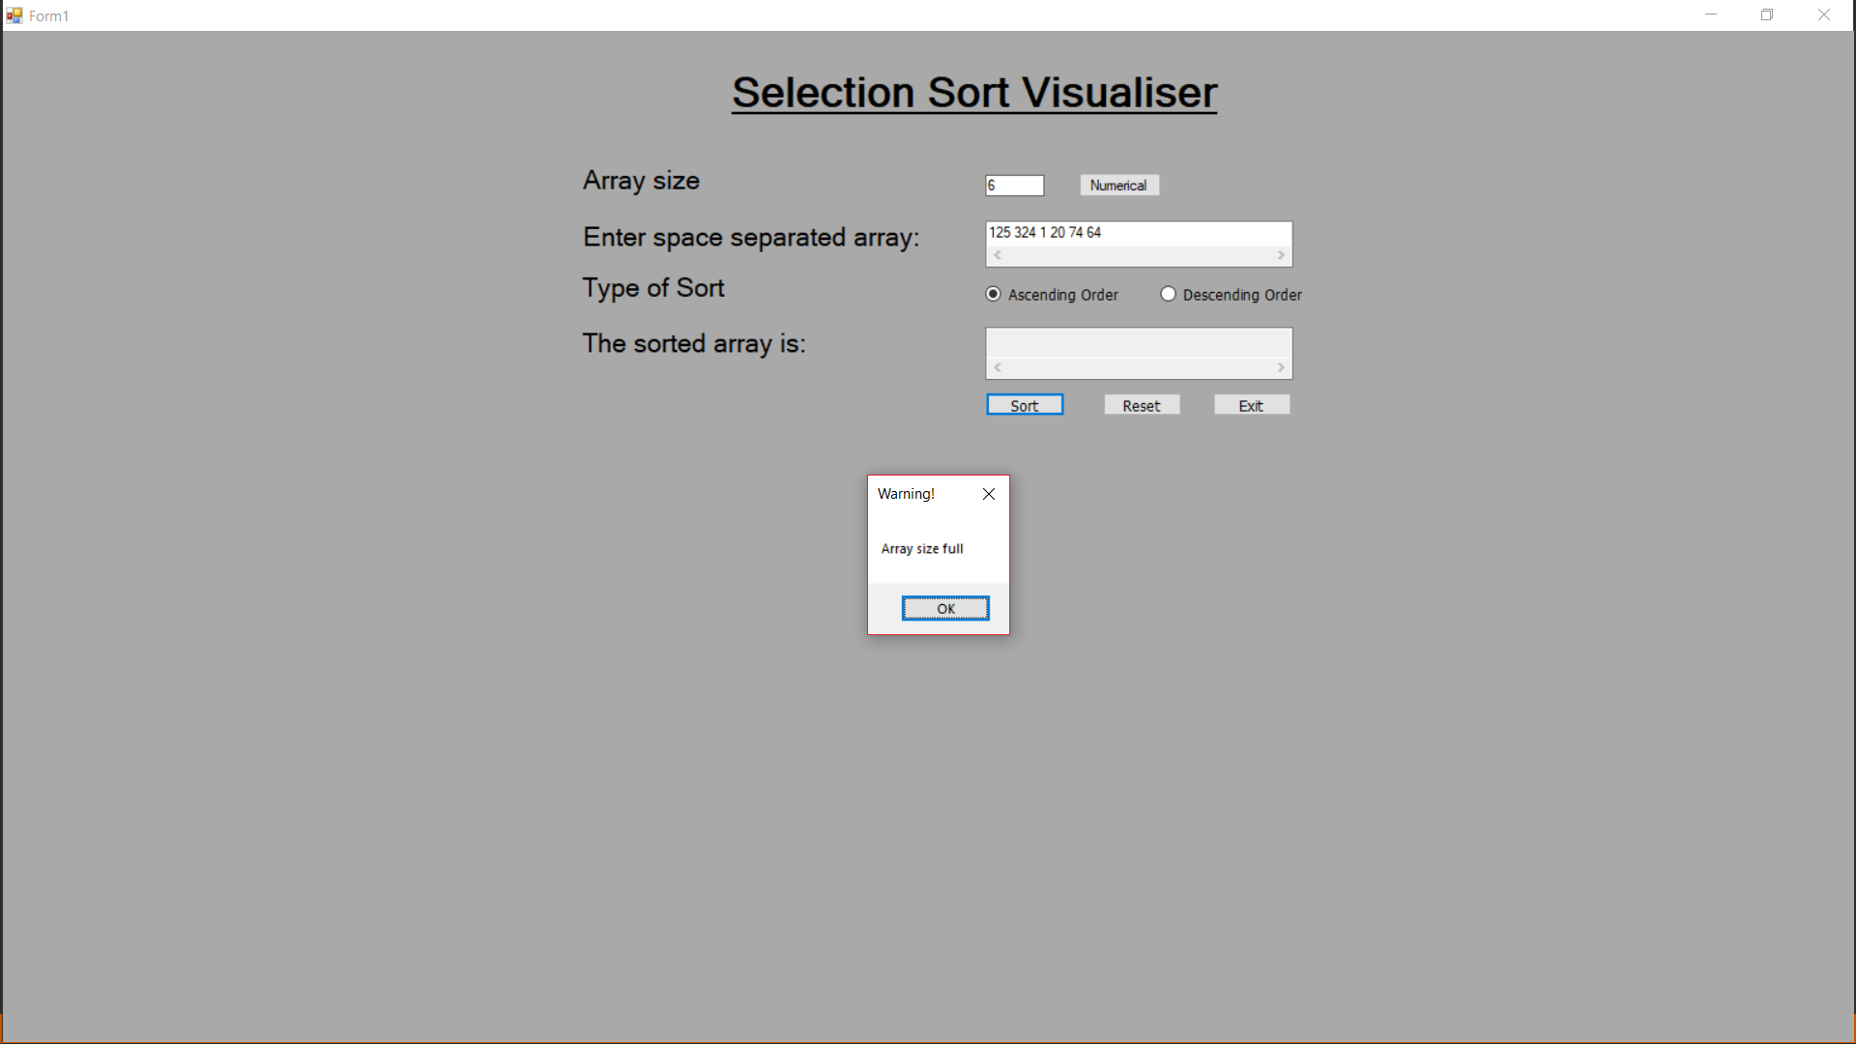
If user enters more number of entries then array size he/she provided.

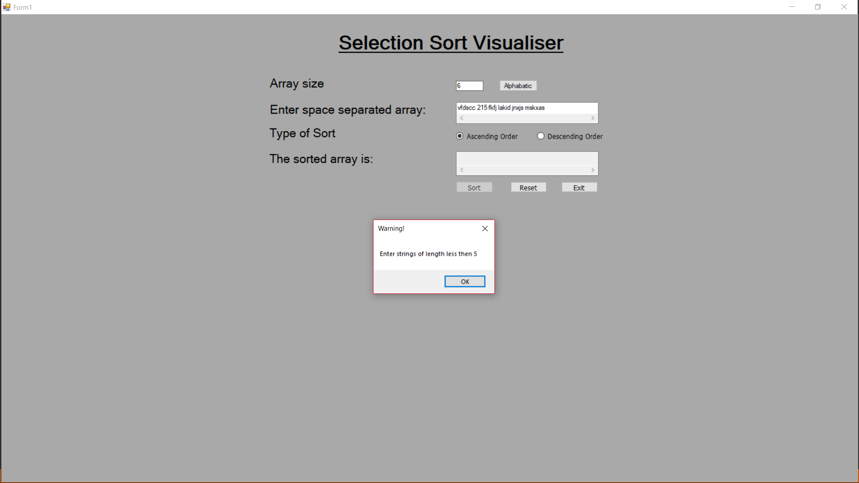
If user selects alphabetical sorting type and enters string of length greater than 5.

Visualization:
For better animation effects User should enter <17 Decimals as input.
TWO MODES OF VISUALIZATION:
- ARRAY
- GRAPH
Red node represents the current element.
Yellow node represents the node having minimum value in that specific iteration.
White nodes are the nodes containing values greater than the minimum value of element in one pass of array.
Swapping of red and yellow nodes of array is shown just below the animated array for better understanding.
A proper delay is given for comparison of the numbers for better visualization.
- *The same applies for the graph visualization also.

